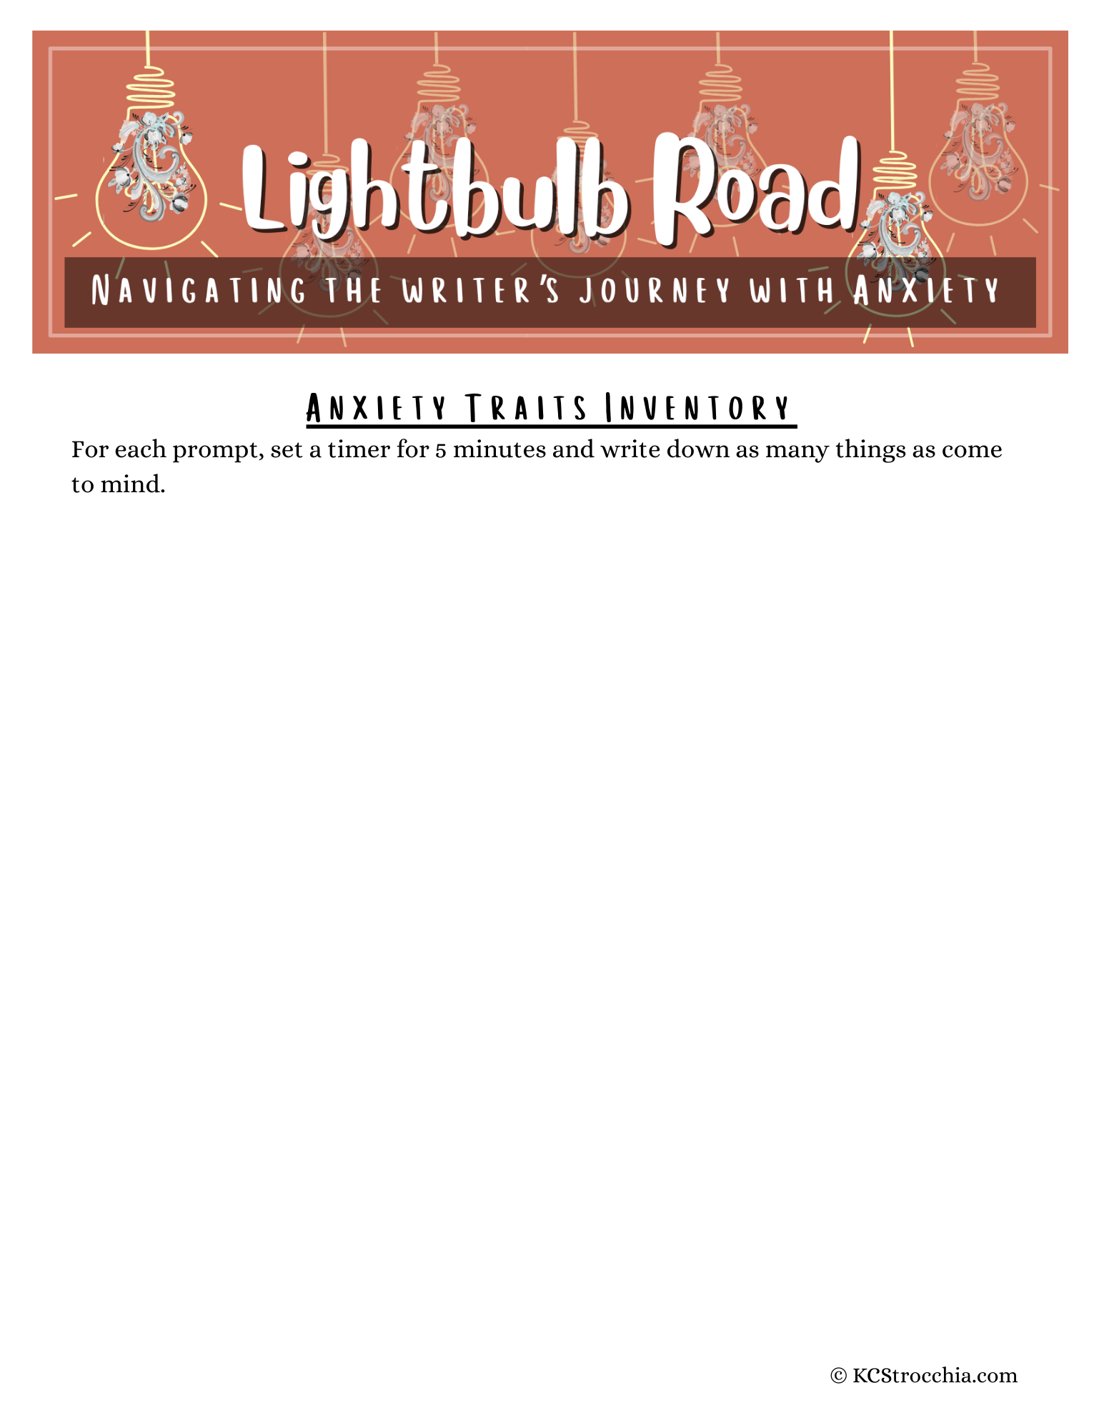

Things your character might worry about obsessively... | Things your character might be irrationally afraid of... | How your character might react to anxiety-producing situations...
1.  2.  3.  4.  5.  6.  7.  8.  9.  10.  11.  12.  13.  14.  15. | 1.  2.  3.  4.  5.  6.  7.  8.  9.  10.  11.  12.  13.  14.  15. | 1.  2.  3.  4.  5.  6.  7.  8.  9.  10.  11.  12.  13.  14.  15.

Things that trigger these worries, fears, & anxiety reactions... | Self-care needs that might reduce the impact of worries, fears, & reactions... | How these worries, fears, & anxiety reactions might impact relationships...
1.  2.  3.  4.  5.  6.  7.  8.  9.  10.  11.  12.  13.  14.  15. | 1.  2.  3.  4.  5.  6.  7.  8.  9.  10.  11.  12.  13.  14.  15. | 1.  2.  3.  4.  5.  6.  7.  8.  9.  10.  11.  12.  13.  14.  15.
