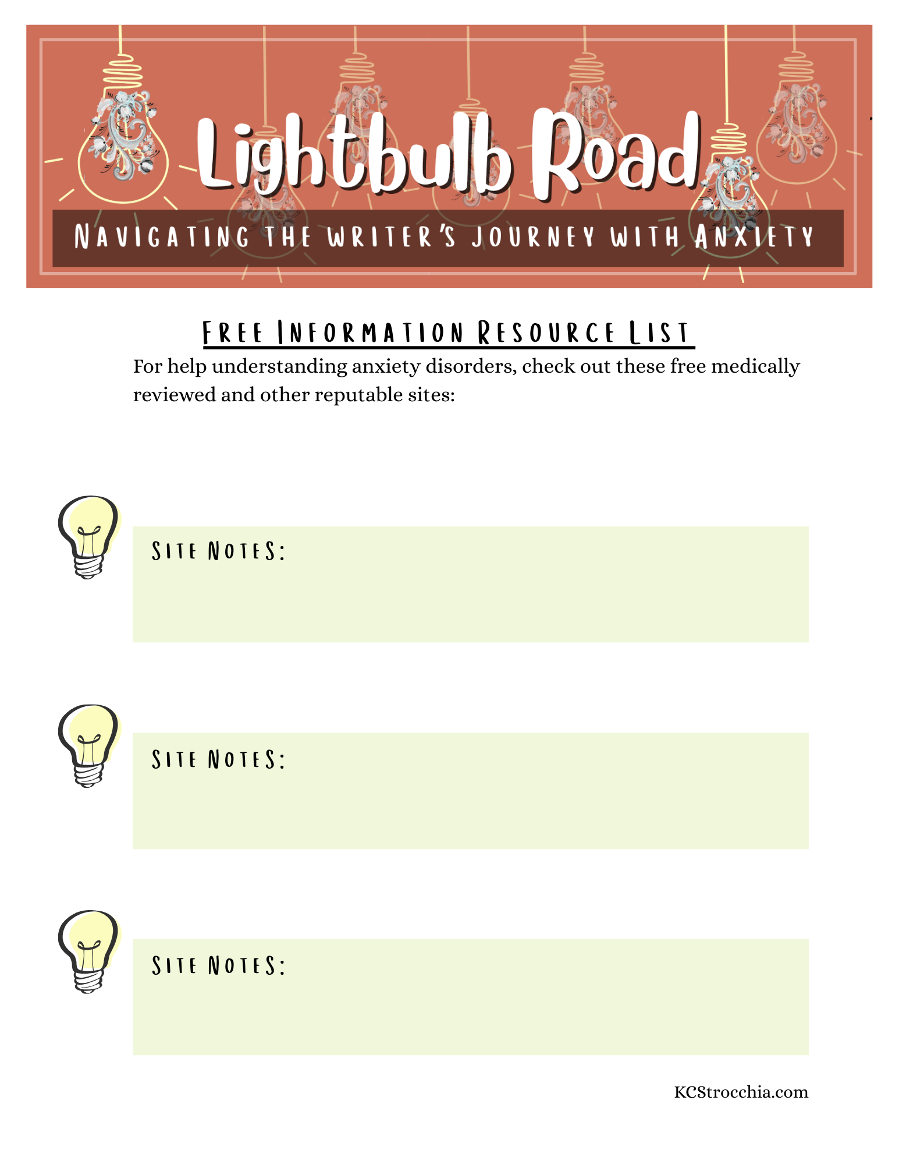

The Mayo Clinic
https://www.mayoclinic.org/diseases-conditions/anxiety/symptoms-causes/syc-20350961

Cleveland Clinic
https://my.clevelandclinic.org/health/diseases/9536-anxiety-disorders

National Institute of Mental Health
https://www.nimh.nih.gov/health/topics/anxiety-disorders

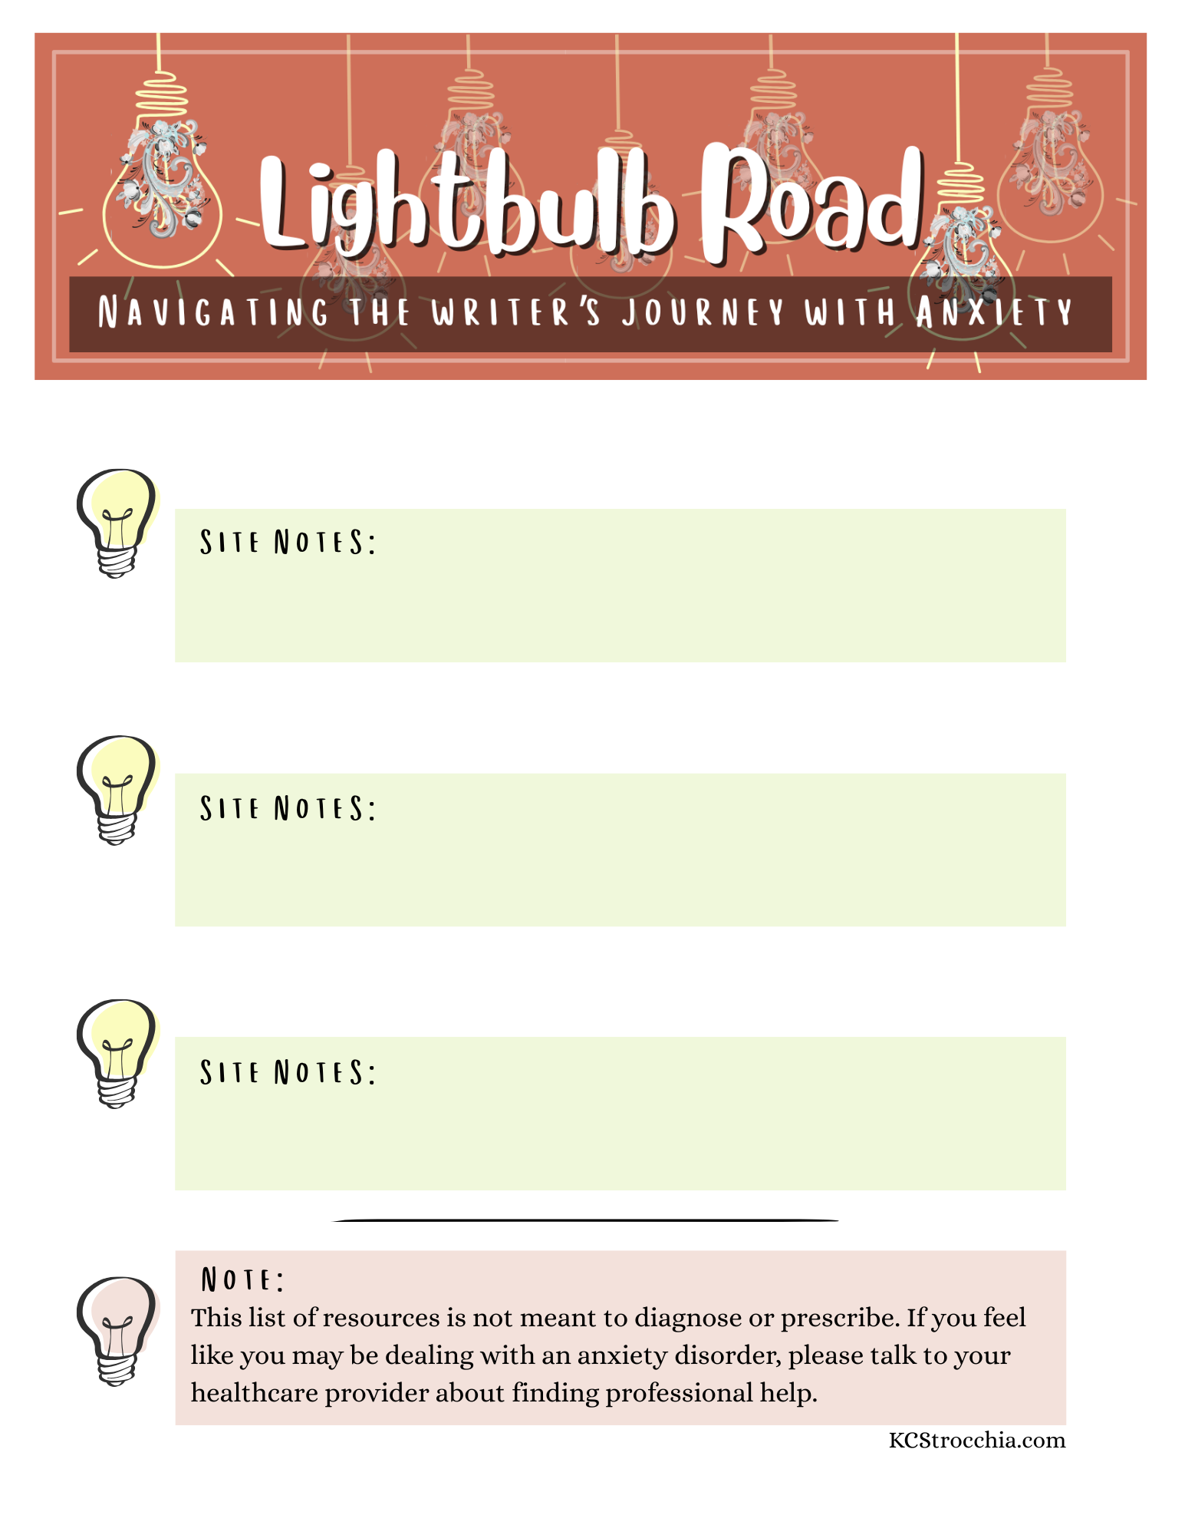

Healthline
https://www.healthline.com/health/anxiety-disorder-symptoms#ways-to-reduce-anxiety

Very Well Mind
https://www.verywellmind.com/anxiety-disorder-2510539

Psychology Today
https://www.psychologytoday.com/us/basics/anxiety

